West Butterwick C of E Primary School
Trentside Federation

This month has continued to be busy and we have spent time thinking about what Our Vision and School Values mean to us.
At the Trentside Federation, building a ‘community of hope’ underpins our vision. Hope and resilience are at the heart of everyone’s learning, encouraging our capacity for reflective thought.
We aim to empower everyone through their learning and relationships, so that all can be ‘agents of positive change’ for themselves, our schools, our local communities and the wider world.
We value everyone as they are. Everyone matter in their uniqueness and everyone is valued.

On Tuesday 2nd November, the School Council went to the Blessing of the Poppies at St Mary’s Church. Here is the poem that they read.
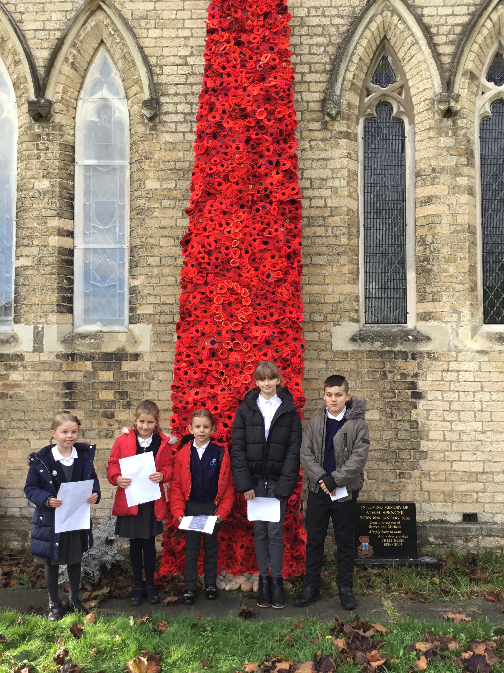

When I see a poppy
When I see a poppy,
I am still.
I am calm.
I am quiet.
Theses poppies here today remind us of soldiers and families.
These poppies here today remind us of times that are near and far away.

When I see a poppy,
I am thoughtful.
I am respectful.
I am quiet.
Theses poppies here today remind us all the fighting that has taken place.
These poppies here today remind us of the peace we have today.

During October we also learnt about Black History Month and completed a number of different activities.

