Art

Opens our eyes to the rich colours, patterns and textures of the world around us.

Curriculum Intent
Our art curriculum is intended to engage, inspire, and challenge pupils, equipping them with the knowledge and skills to experiment, invent, and create their own works of art. We encourage children to develop the courage to take creative risks and learn from mistakes, building resilience. Through studying diverse artists and cultures, pupils develop respect for different traditions and ways of seeing the world. We aim to foster a lifelong appreciation for art and its power to communicate and enrich lives.



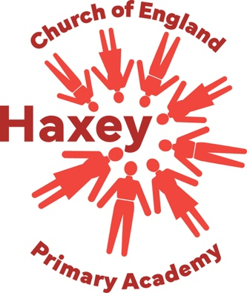
Vision
Developing hope & resilience • Building a community of aspiration
Inspired by the love & teachings of Jesus Christ to be the best that we can be

Values
Hope Love Courage Resilience Respect Wisdom

