Music

We express ourselves even when we don’t have the words.

Curriculum Intent
Our music curriculum nurtures creativity, confidence and community. Rooted in our Christian values, we use music to celebrate individuality, encourage collaboration and support spiritual growth. Through engaging and inclusive experiences, children develop musical skills, resilience and a lifelong love of music, empowering them to express themselves and connect with others.

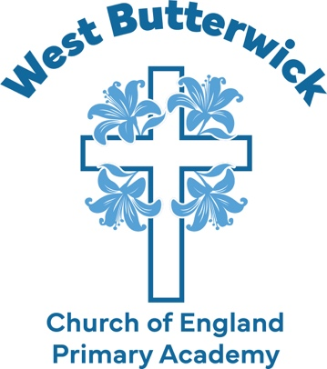

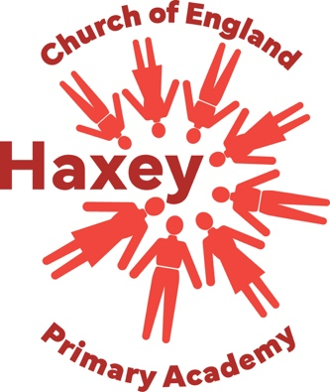
Vision
Developing hope & resilience • Building a community of aspiration
Inspired by the love & teachings of Jesus Christ to be the best that we can be

Values
Hope Love Courage Resilience Respect Wisdom

